

Practices for Secure Software Report

Table of Contents
Document Revision History 3
Client 3
Instructions 3
Developer 4
1. Algorithm Cipher 4
2. Certificate Generation 4
3. Deploy Cipher 4
4. Secure Communications 4
5. Secondary Testing 4
6. Functional Testing 4
7. Summary 4
8. Industry Standard Best Practices 4

Document Revision History

Version | Date | Author | Comments
1.0 | 02/21/26 | Leonard Foy

Client



Instructions

Submit this completed practices for secure software report. Replace the bracketed text with the relevant information. You must document your process for writing secure communications and refactoring code that complies with software security testing protocols.

- Respond to the steps outlined below and include your findings.
- Respond using your own words. You may also choose to include images or supporting materials. If you include them, make certain to insert them in all the relevant locations in the document.
- Refer to the Project Two Guidelines and Rubric for more detailed instructions about each section of the template.

Developer

Ishmael (DEVTag)

Algorithm Cipher

The encryption method used in this project is SHA-256. SHA-256 is a secure hash algorithm that converts data into a fixed 256-bit value called a checksum. It is used to verify data integrity, meaning it helps confirm that information has not been changed.
SHA-256 does not use encryption keys because it is a one-way hash function. Once the data is hashed, it cannot be reversed back to the original input. It is widely used in modern systems because it is secure and resistant to tampering.
In this project, SHA-256 was used to generate a checksum for a unique data string. If the data changes, the checksum changes, which helps detect unauthorized modifications.
Over time, older algorithms such as MD5 and SHA-1 became vulnerable to attacks. SHA-256 remains secure and is considered an industry standard today.

Certificate Generation
Insert a screenshot below of the CER file.
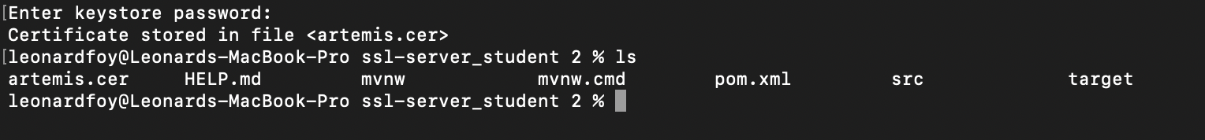

Deploy Cipher
Insert a screenshot below of the checksum verification.

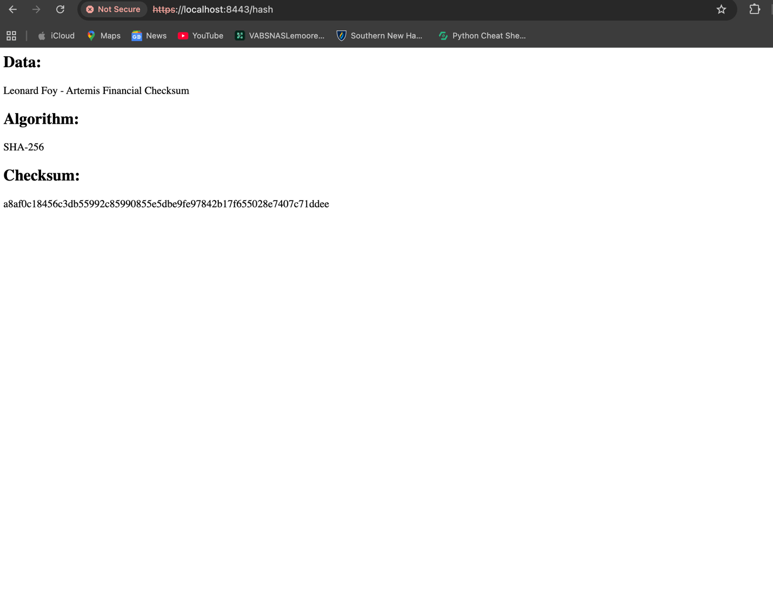

Secure Communications
Insert a screenshot below of the web browser that shows a secure webpage.

Secondary Testing
Insert screenshots below of the refactored code executed without errors and the dependency-check report.

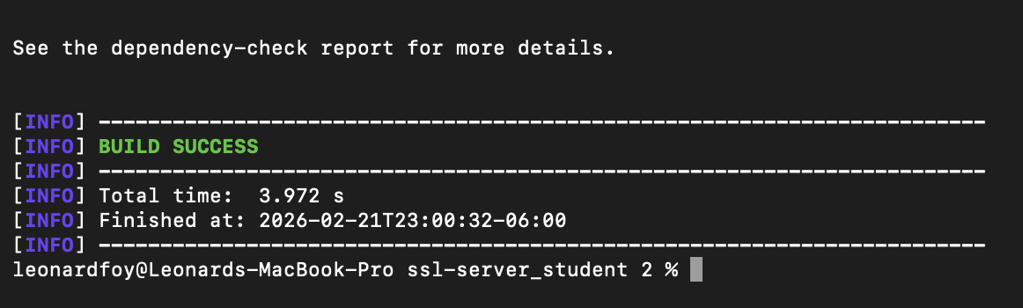

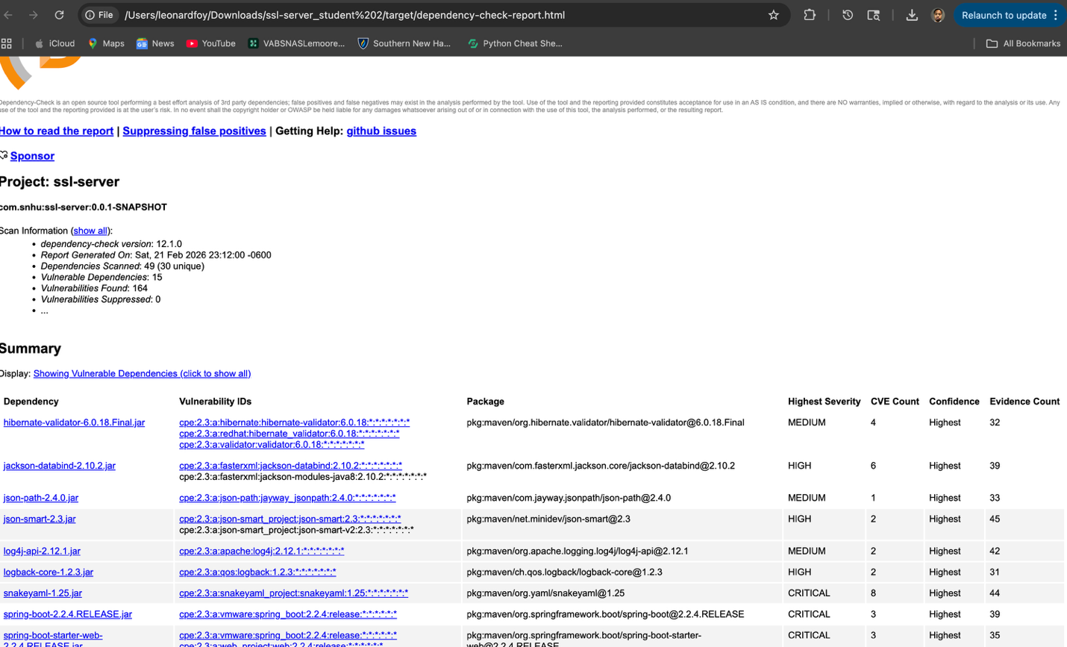

Functional Testing
Insert a screenshot below of the refactored code executed without errors.

[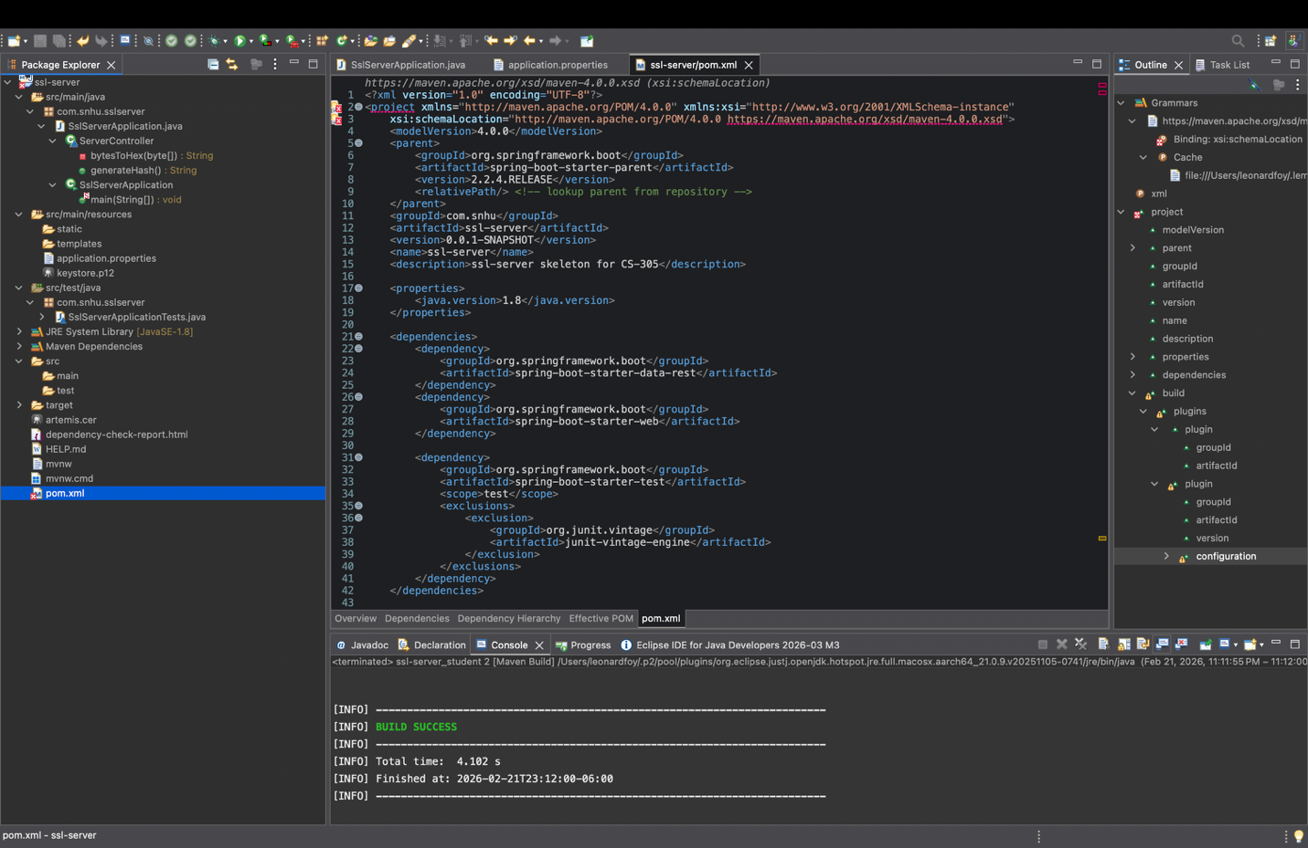

Summary

The code was updated to improve security by adding SHA-256 hashing and enabling HTTPS communication. A certificate was generated, exported, and verified. Static testing confirmed that no new security issues were introduced.

Industry Standard Best Practices

Industry standard security practices were followed by using SHA-256 for hashing and a 2048-bit RSA key for HTTPS. Established Java security libraries were used instead of custom code.

